The Wondrous World
Of Robotics

Rachel Hilton

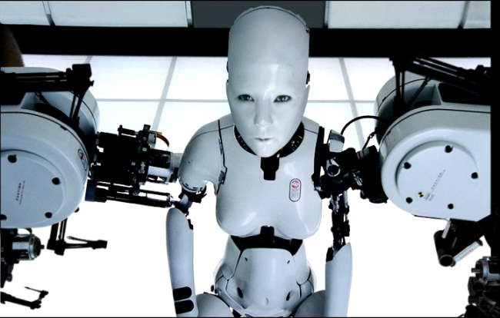

LE 1310 – Mind, Machine, Consciousness
Jerry Giles
Due Date: May 5, 2014
“A spark could be enough to set them ablaze.”
- Suzanne Collins
This quote from a popular book series just about sums up the world of robotics, which has come a long way over the years. Early in history Ctesibus (an ancient Greek engineer) set out and created organs and water clocks with movable figures around 250 B.C. Centuries later, in 1495, Leonardo da Vinci designed mechanical armored knights. By 1921 the first mention of the term robot appeared in Czech author Karel Capek’s "Rossum's Universal Robots". These ideas of machines to aid man led to the establishment of Isaac Asimov’s “Laws of Robotics” in 1942, as well as the Turing Test in 1950 which tests whether an entity has intelligence like that of a human or not (University of Auckland, 2014). Robotics is a field of study that has brought new knowledge, insight, and advancements into the world we live and make it a far wondrous place.
When most people think of robots these days, they’re actually thinking of artificial intelligence (AI) entities. As of late, advanced robotics like AI may have seemed like a pipedream only existent in science fiction television and film, but recent developments have led to major progresses in this area of expertise. Current projects like Japan’s Geminoids, HIRO, and ASIMO and New Zealand’s BabyX are paving the way for a new world where machine driven entities and humans coexist.
According to the Merriam-Webster Dictionary, robotics is the study of “technology dealing with the design, construction, and operation of robots in automation”. Some robots can do work by themselves while others must be told what to do by a person. Basic robots already grace many people’s homes in the form of the Roomba vacuum cleaner. The Roomba uses infrared sensors to detect room size and obstacles to avoid while cleaning the floor. This little sucker also has the ability to connect itself to its charger when it’s low on batteries. Although the Roomba cannot carry on a conversation with a person, it is still a great accomplishment when it comes to robotics (Layton, 2005).
Robots can be used in place of humans under many circumstances. For example, an eight-legged robot named Dante II was sent into Mount Spurr, a volcano in Alaska, to measure composition and temperature of the fumeroles coming from the volcano’s vents. People controlled Dante II from 80 miles away, but Dante II also managed to operate on his own at times using onboard sensors and computers. Dante II gave the science world new insight into volcanic gas compilation and showed people that robots could use precision and efficiency to do jobs in territories that were deemed unsafe for human travel (Wettergreen, 1999).
Today, robots are being used for more than just housecleaning and traveling uncharted territories. In fact, many people fear that robots are already putting their jobs at risk. According to NBC News “As IBM's Watson proved on Jeopardy, robots are becoming smarter than people. They also make fewer mistakes and they don't get bored.” This article also points out that in 2013 it was expected that 1.2 million industrial robots would be working worldwide. Human employees from pharmacists to lawyers and drivers to astronauts, soldiers, rescuers, store clerks, and babysitters are hypothesized to become obsolete in the near future at the hands of robots (Aquino, 2012). This is a phenomenal leap in the name of technology, but is a scary thought when seeking job security for some.
Luckily, the increasing supply of robots being used in some fields increases the demand of workers who develop and maintain robots. With robots being used for jobs that have a high risk of injury, workplace fatalities and irritating ailments like carpal tunnel will decrease; not to mention mistakes commonly made by humans during risky medical procedures can be avoided with the use of properly programmed robots. Until recently, robots had mainly performed tasks on assembly lines at food and machine production companies, but humans are rapidly beginning to understand the contributions they can bring to society (Huse, 2001).
Countries all over the world have come to expect different things from robots. Figure 1 shows the top countries with the highest rated robot density per 10,000 manufacturing workers as of 2008. Japan’s number almost doubles that of Singapore, who ranks second in robot density. At the time this graph was made there were 1 million industrial robots laboring away in the world. In 2007, $18 trillion was invested in industrial robotics worldwide (Guizzo, 2008). The total involvement in the robotics world insists that it must be the wave of the future.
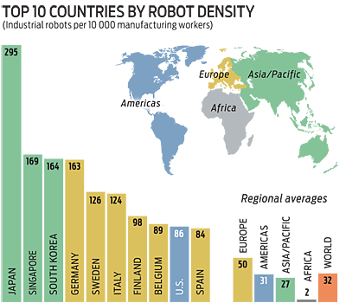
Figure 1: Guizzo, E. (2008). The Rise of the Machines.
Time Magazine speculates that Japan may be so involved with the robotics world because of ancient beliefs that a tamashii or spirit can enter any object from rocks to humans and everything between. Robotics engineer, Osamu Kozaki states: “Everything is equal. We have no borders between robots and people. In the foreign stories, robots are always the enemies. In Japan, they’re our friends.” Professor Hiroshi Ishiguro, director of the Intelligent Robotics Laboratory at Osaka University says this is the reason why Japanese people don’t hesitate when it comes to making a human-like robot. People should have no qualms accepting these new creatures with this way of thinking (The Global Mail, 2013).
Figure 2 shows a breakdown of industries and applications that robots were used for as of 2008. I can only imagine what expertise these entities will hold in the future. As the study and expansion of robots meets advancements in technology, robotics development should know no bounds. No one knows what the future holds, but some have a pretty good idea. Some robotic developments already underway include nickel-coated microbots that can administer drugs directly to sensitive areas of the body like the brain and eyes, the iCub toddler-bot who can learn languages and even anticipate the end of sentences, and a solar-powered prospecting bot that will be used to drill holes in hopes of finding water on the moon. Within no time robots should be ubiquitously co-mingling with humans (Atherton, 2013).
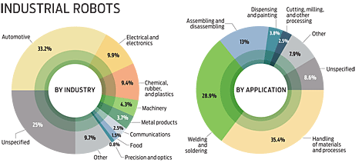
Figure 2: Guizzo, E. (2008). The Rise of the Machines.
Robotics has been a field of interest for thousands of years and now that we have reached the age of technology nirvana we finally have the means to make things happen. From basic robots to Artificial Intelligence, robots will aide humans in tasks ranging from assembly line functions to precision surgeries and everything in between. These machines will ensure the health and safety of some and bring us a wealth of knowledge about lands currently unexplored by humans. Robots will multiply the world over and I can’t wait to see what they have in store for us.

Bibliography

Aquino, J. (2012). Nine Jobs that Humans May Lose to Robots. Retrieved from Careers on NBC News.com: http://www.nbcnews.com/id/42183592/ns/business-careers/t/nine-jobs-humans-may-lose-robots/#.U2IHRvmSywQ.

Atherton, K. D. (2013, September 15). Future of Robots. Retrieved from Popular Science: http://www.popsci.com/category/tags/future-robots.

Guizzo, E. (2008, December 1). The Rise of the Machines. Retrieved from IEEE Spectrum: http://spectrum.ieee.org/robotics/industrial-robots/the-rise-of-the-machines/0.

Huse, B. (2001, December 13). How Robots will Affect Future Generations. Retrieved from Robotics Online: http://www.robotics.org/content-detail.cfm/Industrial-Robotics-Featured-Articles/How-Robots-Will-Affect-Future-Generations/content_id/834.

Layton, J. (2005, November 3). How Robotic Vacuums Work. Retrieved from How Stuff Works: http://electronics.howstuffworks.com/gadgets/home/robotic-vacuum2.htm.

The Global Mail. (2013, February 21). Japan's Love Affair with Robots, Explained. Retrieved from TIME: http://newsfeed.time.com/2013/02/21/watch-japans-love-affair-with-robots-explained/.

University of Auckland. (2014). Robotics History Timeline. Retrieved from Robotics Research Group:http://robotics.ece.auckland.ac.nz/index.php?option=com_content&task=view&id=31.

Wettergreen, J. E. (1999). Dante II: Technical Description, Results, and Lessons Learned. The International Journal of Robotics Research, 621-649. Retrieved from http://www.ri.cmu.edu/pub_files/pub2/bares_john_1999_1/bares_john_1999_1.pdf.
* Title Page Image Taken From http://www.cyberpunkreview.com/movie/style/short-film/bjork-all-is-full-of-love/.

